

Clinic Management System Requirements Specification

Version 1.0

April 5, 2019

Submitted by:
Besa Gashi
Anilda Disha
Gerjan Kallcishta
Ina Dezhgiu
Sindi Begteshi
Xhejdi Coku

Accepted by: M.Sc. Igli Hakrama
Table of Contents
1. Executive Summary 3
1.1 Project Overview 3
1.2 Purpose and Scope of this Specification 3
2. Product/Service Description 3
2.1 Product Context 3
2.2 User Characteristics 3
2.3 Assumptions 3
2.4 Constraints 3
2.5 Dependencies 4
3. Requirements 4
3.1 Functional Requirements 5
3.2 Non-Functional Requirements 5
3.2.1 User Interface Requirements 5
3.2.2 Usability 5
3.2.3 Performance 6
3.2.4 Manageability/Maintainability 6
3.2.5 System Interface/Integration 7
3.2.6 Security 8
3.2.7 Data Management 8
3.2.8 Standards Compliance 8
3.2.9 Portability 8
3.2.10 Other Non-Functional Requirements 9
3.3 Domain Requirements 9
4. User Scenarios/Use Cases 9
APPENDIX 10
Appendix A. Definitions, Acronyms, and Abbreviations 10
Appendix B. References 10
Appendix C. Requirements Traceability Matrix 10
Appendix D. Organizing the Requirements 12

Executive Summary

Project Overview

Nowadays the importance of technology is getting bigger with every minute passing by. Also with the population rate increasing in a high pace, it is being harder to keep track of all the information inside a business. When it comes to a medical clinic, a patient’s information should be kept in maximum security and there’s when technology makes this task very easy. To make an administrator and staff’s work easier, we thought of creating a software, which will be used by them.
This software intends to make keeping track of patients, supplies, workers, and financial activities easier than before.

Purpose and Scope of this Specification

The purpose of this specification is providing a detailed and précised information. Regarding the target audience, this software will be used by the administrator and the rest of the staff, so they can have better and faster communication, thus making their daily tasks easier.

Furthermore this system aims to:
- Make medical analyses in a faster and efficient way.
- Give results in a shorter time than usual.
- Keep records of patients and for their privacy, identify them with a unique barcode.
- Improve decision making across finance, HR etc.
- Manager has access non-stop to see how the staff is working, thus making it easier to make decisions

Product/Service Description

Product Context

Clinic Management System will be created in such way to give a helping hand to the persons who will use it. It aims to better keep track of suppliers, staff employees, salaries and patients.

User Characteristics

Users that are going to have access on the software include :
- Administrator:
  - Can add new users.
  - Can manage the users login credentials.
  - Will give access to the users .
  - Will have access to the whole system.

- Financier
1. Will deal with salaries.
2. Will take care of inventory.

- Human Resource
1. Will add new employees.
2. Will make a monthly job evaluation.

- Medical Staff
1. Can view their patients.
2. Can update their information.

- Receptionist
1.Set appointments for new patients.
2.Generate receipts.

Assumptions

It is assumed that this system will be accessed from the web browser over the computers as long as they have connection to the internet.

It is assumed that the users are with good knowledge of English language.

It is assumed that the administrator will be the first user that can have access in the system , so that he/she can add the other users.

It is assumed that only the doctor will have access over patient’s information and this information is fully confidential.

Constraints

- Every user should have their own computer so that it is easier for them to use the system.
- Since it will be a web application it will require a good and established connection to the internet for full time usage.
- Users should keep communication during all working hours for them to have a more efficient work and take better decisions.

Dependencies

Since the administrator has the main access to the whole system, there are some dependencies which need to be taken into consideration:
- If the administrator is not registered to the system, other users can not be registered.
- If the financier does not make reports, admin will not be able to see them and make decisions.
- If HR specialist does not keep track of working days of each employee, then the financier will not be able to calculate the wage of them.
- If receipt is not generated, the revenue will not be included in the balance sheet.

Requirements

Functional Requirements

Priority Definitions
- Priority 1 – The requirement is a “must have” as outlined by policy/law
- Priority 2 – The requirement is needed for improved processing, and the fulfillment of the requirement will create immediate benefits
- Priority 3 – The requirement is a “nice to have” which may include new functionality

The requirement numbering has a scheme - BR_0## (BR for Business Requirement).

Req# | Requirement | Comments | Priority | Date Reviewed | Approved
BR_01 | The system should have a Software  which will be used by 5 different users. | They will be the Manager,Finance department, Medical staff, HR, Administartion staff | 1 | 2/03/19 | Besa Gashi,  Anilda Disha
BR_02 | The manager(admin) will give access to other users | He/She will provide them with login information. | 1 | 2/03/19 | Besa Gashi,  Anilda Disha
BR_03 | The manager will update users. | In case if the employees will change there will be a need for some updates | 1 | 2/03/19 | Besa Gashi,  Anilda Disha
BR_04 | Manager will generate reports. | He will generate reports to see how is going the overall situation in company. | 1 | 2/03/19 | Besa Gashi,  Anilda Disha
BR_05 | Manager will generate graphs. | They will help him of the company to take best decision. | 1 | 2/03/19 | Besa Gashi,  Anilda Disha
BR_06 | The administrative staff will take the record of the patients. | These records will be registered on the system by the administrative staff. | 1 | 2/03/19 | Besa Gashi,  Anilda Disha
BR_07 | The medical staff will view all the patients and their records, also there tests. | They will update the results online on the system, and also give a short description of the test results. | 1 | 2/03/19 | Besa Gashi,  Anilda Disha
BR_08 | HR will register and manage all the employees. | All the employees’ information should be in the system. | 1 | 2/03/19 | Besa Gashi,  Anilda Disha
BR_09 | HR will delete update the employees and the information. | They should always be ready for future changes on the staff or their informations. | 1 | 2/03/19 | Besa Gashi,  Anilda Disha
BR_10 | The finance department will keep the inventory records. | All inventory records should be in the system, in order to make the better use of the materials needed for the tests, The materials used are very expensive so this process will define the amortization time and help the manager to make better decisions. | 2 | 2/03/19 | Besa Gashi,  Anilda Disha
BR_11 | The finance department will make the balance sheets and other financial statements needed for the operations. | This will help the manager to evaluate also the performance of the business, even though this is a medical service, in the end it is still a business. | 2 | 2/03/19 | Besa Gashi,  Anilda Disha
BR_12 | The finance department l also calculate the salaries. | Finance will calculate the salaries and then pass it to HR | 1 | 2/03/19 | Besa Gashi,  Anilda Disha
BR_13 | The manager (admin) will have access in every part of the system. | In order to make better decisions and also make evaluations. | 1 | 2/03/19 | Besa Gashi,  Anilda Disha

Non-Functional Requirements

User Interface Requirements

Our application will be a software; that will be placed on the computer of the clinic.

The first page is going to be a page with 2 big divisions, admin and users, the admin will be the manager, he will have access all over the system. And the second division (users) will be for the staff, medical staff, administrative staff, finance department, and HR. Then the second page will be the log in with an email and password for each user that will be provided form the manager.

Our system will consist of several modules, providing that it will manage the whole company. These modules are the employee module, medical tests module, the patients’ module, the finance module and the report module.
The manager is responsible for adding new users, such as medical staff, HR specialist, administrator and receptionists, to the system, managing the existing ones and viewing their details. After registering a new user, he/she will provide them with their login information so that they can access the system.

On the other hand, the administrative staff will keep the record of the patients and register these informations on the system. The medical staff will make the tests, will see all of the patients’ records and update the test results on the system. The finance will manage the financial part of the system, prepare the financial statements, keep and manage the inventory, also calculate employees’ salaries.
The HR specialist will add new employees, manage existing ones and also manage departments. Other important features will be performance evaluation.

Usability
- The system is easy to use.
- It will be built in such a way that every operation will be context sensitive and obvious to how it works, in order that all users to understand and do their jobs in a more efficient way.

Performance
- Users will have a high performance in completing a specific task of the management system.
- Most of them will be able to use the system very well, without the need of help from the system builder.
Productivity
- The system will be productive meaning that all the tasks will be accomplished easily with the least amount of work and time.
- There will be few or no user errors.
Accessibility
- The system will be accessible at any time by every registered user on the clinic property.

User friendliness
- The system will be delightful to use.
- It shall not be intimidating, frustrating and look as though it demands a lot of time and effort to complete a simple task.

Error tolerance
- The system shall be created in such a way that it will leave no room for error.
- It will be difficult for a simple task to go wrong.

Effectiveness
- The software will aid that all the emplyees to accomplish their job in an effective way and in a shorter time by providing easy tools.
Efficiency
- The system shall provide to the users a fast and reliable way of completing their respective tasks promptly with no difficulties and errors.

Performance
Based on the interviews we made with the manager, we planned software most critical scenarios:
- Registration of the client.
- Generate the price client has to pay depending on the laboratory test they want.
- Management of sales from finance department, and other finance activity including balances and inventories.
- Information update of test results

Capacity
While analyzing the current and forecasting the future demand, we came up with this capacity planning:
Total number of users: 30
Number of current users: 20
80% - 90% of the transactions are accepted to complete within 2 seconds.
If in the future we lack of capacity, we will consider to add additional applications and database servers.

Availability
The software with be geographically restricted in Albania territory.
It will be functioning 16h a day, since the information is accepted to be received daily.
The system needs a high availability and the impact of a downtime on users would be serious. The period of time when the system may be offline to be improved may be some few hours in Sunday. That will give an impact on users in the financial and medical staff department, but at least will not affect the department that deals with clients, because the clinic does not operate on Sunday.

Latency
Speed of the transactions will be faster than 50ms.

Manageability/Maintainability

Monitoring
We will ask reports from managers and stuff that use the software for the problems they have faced, while proving the software, in order to fix them. We will check beforehand response time, transactions per seconds, user logged in, database response query, networking monitoring etc.

Maintenance
The system will be very simple to use and the models are separated from each other with means that the transaction will occur separately, databases will loaded and the activities easy to process. But except of this, we will still make our test in order to define problems before occurring or fix the existing ones. For this will help preventive and corrective maintenance.

Operations
- Add new user, medical staff, HR manager, administrator, receptionist.
- Log in to access the system.
- Keep record of patients.
- Register information in the system.
- Update test results to the system.
- Prepare the financial statements.
- Calculate employers salary.

System Interface/Integration

Systems Interfaces

The system will use protocols of HTTP and HTTPS and also SQL technologies since we will use databases for the clients and staff.
The system will use internet connection as the networking interface.
Based on their position inside the business, different users will have different functionalities.
Since we are restricted in Albania territory, there will be no changes in the time zones.

Security

Protection
- Cloud Firestore Security Rules allows us to control the access of the documents and collections in our database.
- The flexible rules syntax allows us to create different rules that match everything, from all writes to the entire database to operations on a specific document.
- Every request to write or to read something will be completed if only our rules allow it
- Our rules do not allow anyone to access our database.
- Using security rules allows us to write conditions that can check user authentication, validate incoming data, or even access other parts of our database.
- This is to protect our database from any abuse until we have time to customize our rules or set up authentication.

Data Management

- Cloud Firestore is a NoSQL, document-oriented database
- Unlike a SQL database, there are no tables or rows
- Instead, we store data in documents, which are organized into collections
- Each document contains a set of key-value pairs
- All our documents will be stored in collections. Documents can contain sub-collections and nested objects, both of which can include primitive fields like strings or complex objects like lists.
- Collections and documents are created implicitly in Cloud Firestore. If document or collection does not exist, Cloud Firestore creates it.

Standards Compliance
Our application “Clinic Management System” it’s going to respect and fulfill the rules and regulations determined by “LIGJI Nr.9887, datë 10.3.2008, PËR MBROJTJEN E TË DHËNAVE PERSONALE” to provide discretion to the patients.
Also, to “LIGJI Nr. 10 383, datë 24.2.2011 PËR SIGURIMIN E DETYRUESHËM TË KUJDESIT SHËNDETËSOR” for a good and efficient health care service for the patient. Finance department it’s going to take care of generating the bills and also the reports, according to “Drejtoria e Pergjithshme e Tatimeve”.
Our system it’s going to include all the fields and services of the clinic, in a more optimized way, providing the best service for our clients.

Portability
Our software will be python based. Python is an interpreted, interactive, object-oriented programming language. It is also usable as an extension language for applications that need a programmable interface. Finally, Python is portable: it runs on many Unix variants, on the Mac, and on Windows 2000 and later. Python does not need a compiler because it relies on an application (called an interpreter) that compiles and runs the code without storing the machine code being created in a form that you can easily access or distribute. All programming languages require translation from human concepts into a target machine code. Our software won’t need a particular operation system, it may be used by all operating systems.

Domain Requirements
Clinic Management System is aimed to keep track of patients, supplies, workers, and financial activities inside a clinic. This will help the business to be better organized and base their decisions in detailed reports and information.
Since when it comes to medical data the security and confidentiality are at a peak importance, the result of the lab tests of patients will be seen only by the doctors who performed them. The front desk or receptionists will have access to only the patients list making it able for them to add new patients at registration. The HR specialist will see the information about the employees. The financial specialist will have access to the financial records like receipts, suppliers etc.
The administrator of the clinic will be able to access information about all the departments , leaving out of course the confidential information about patients like their test results.

User Scenarios/Use Cases

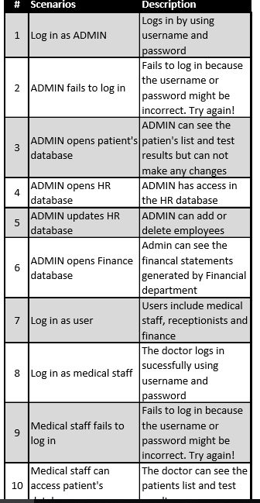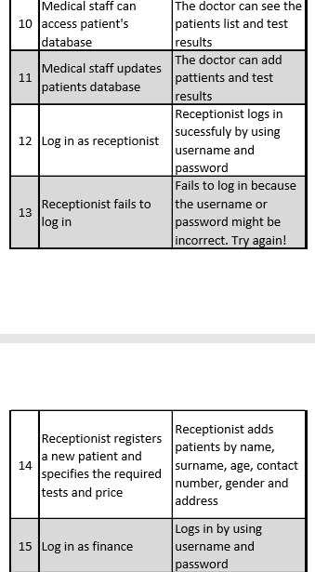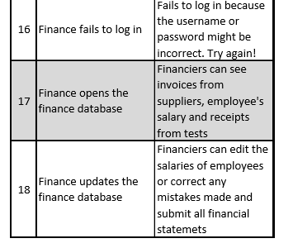

Use Case
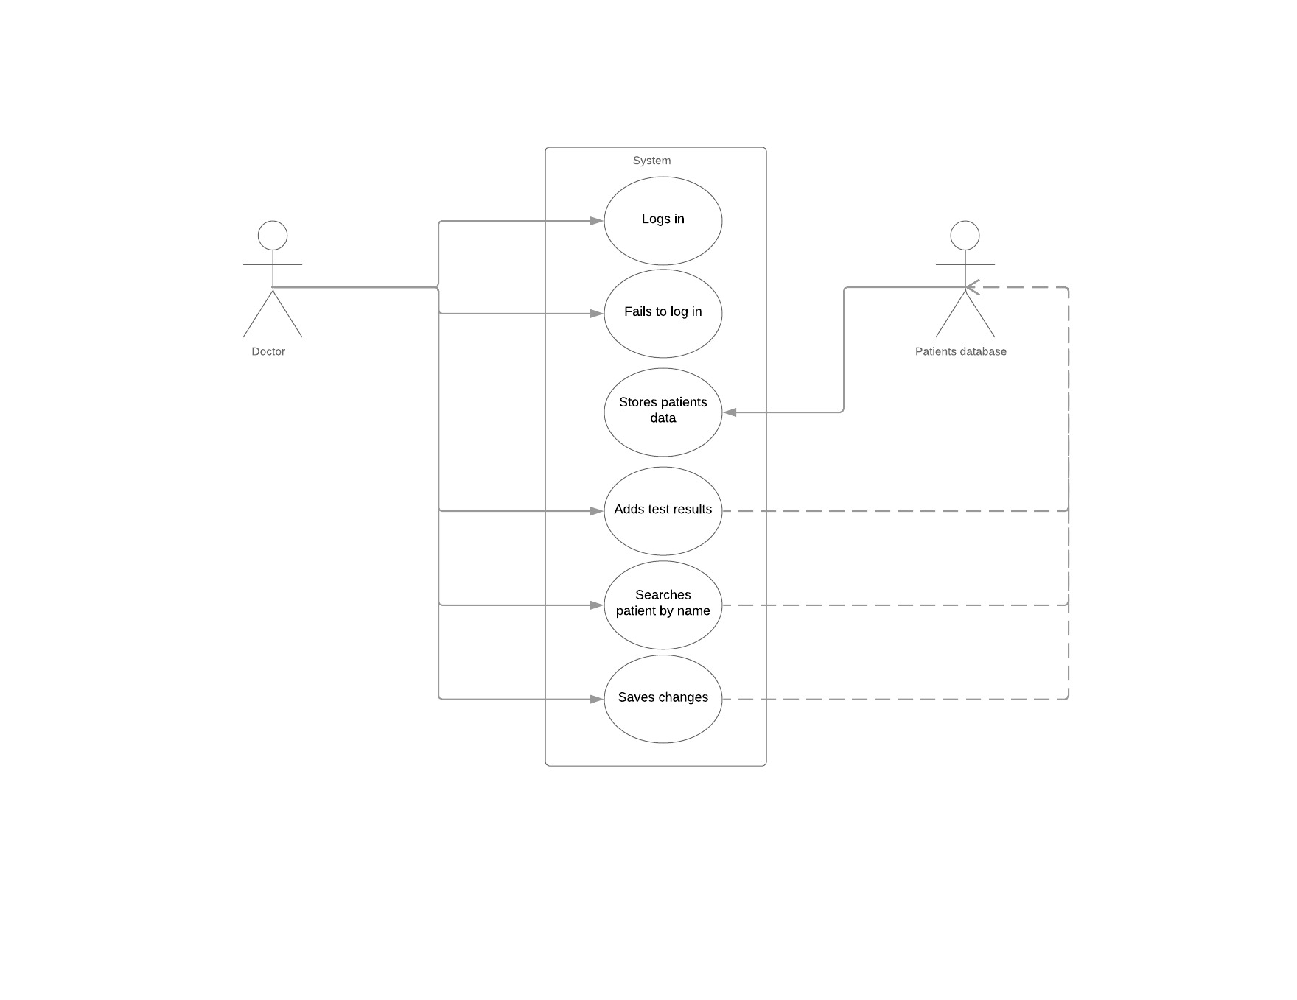
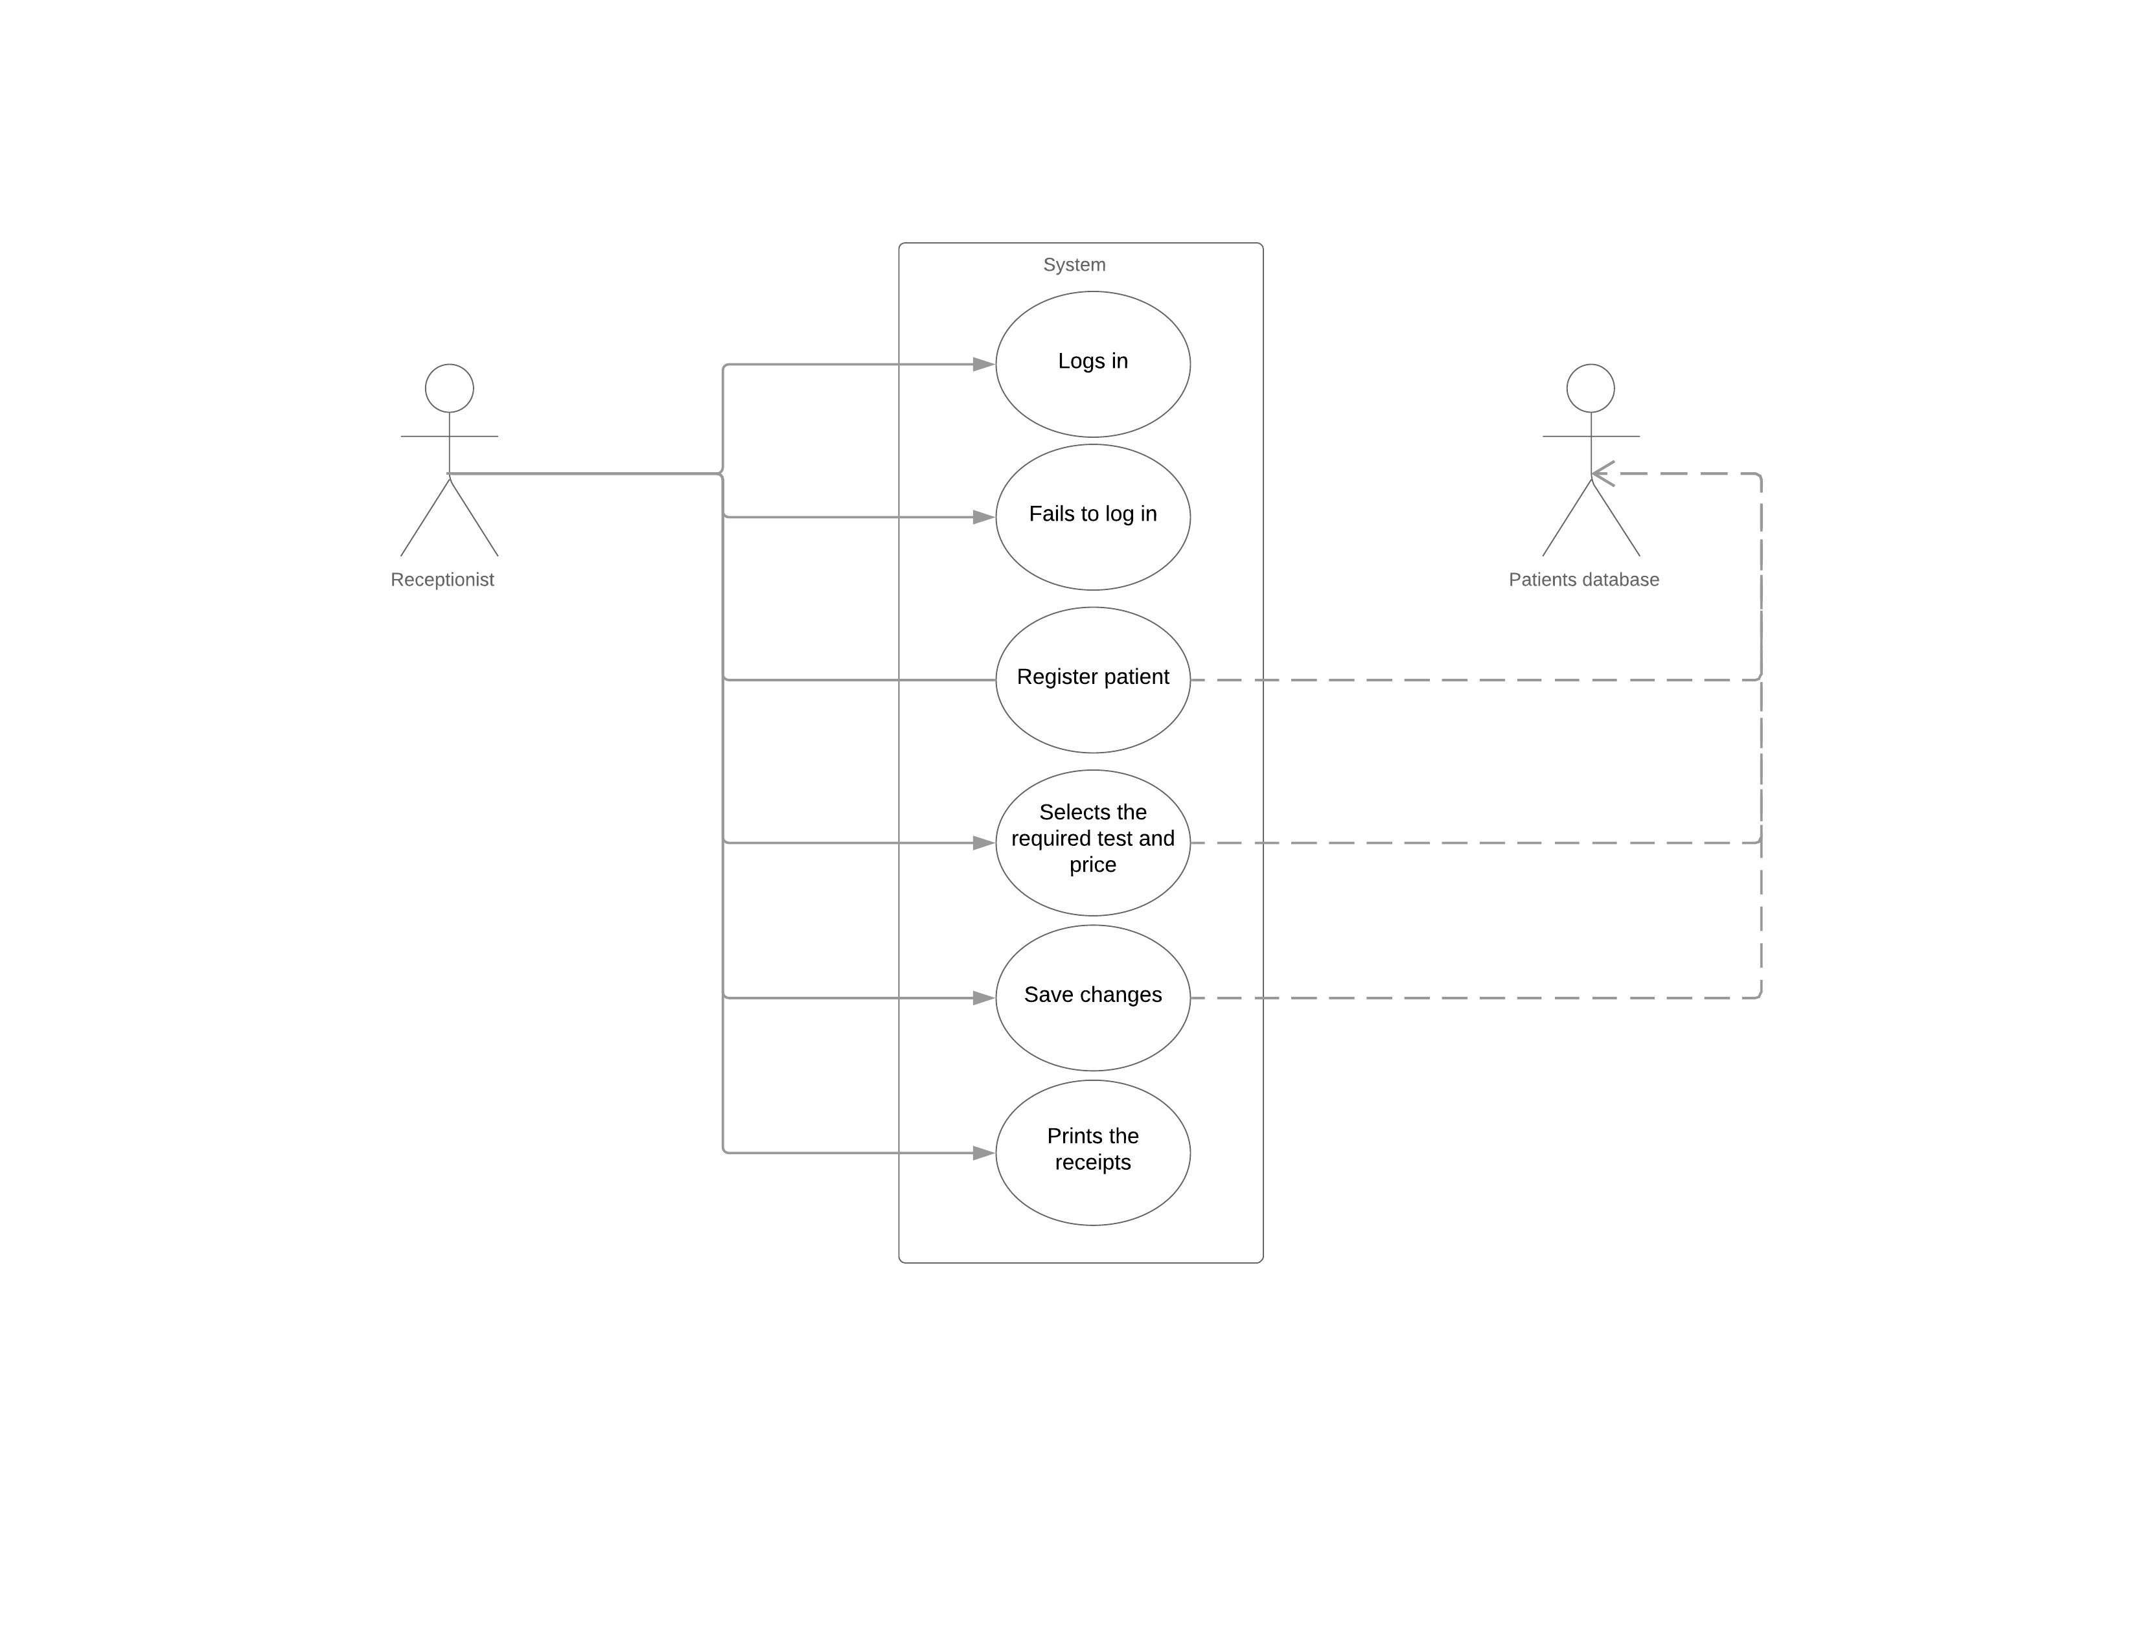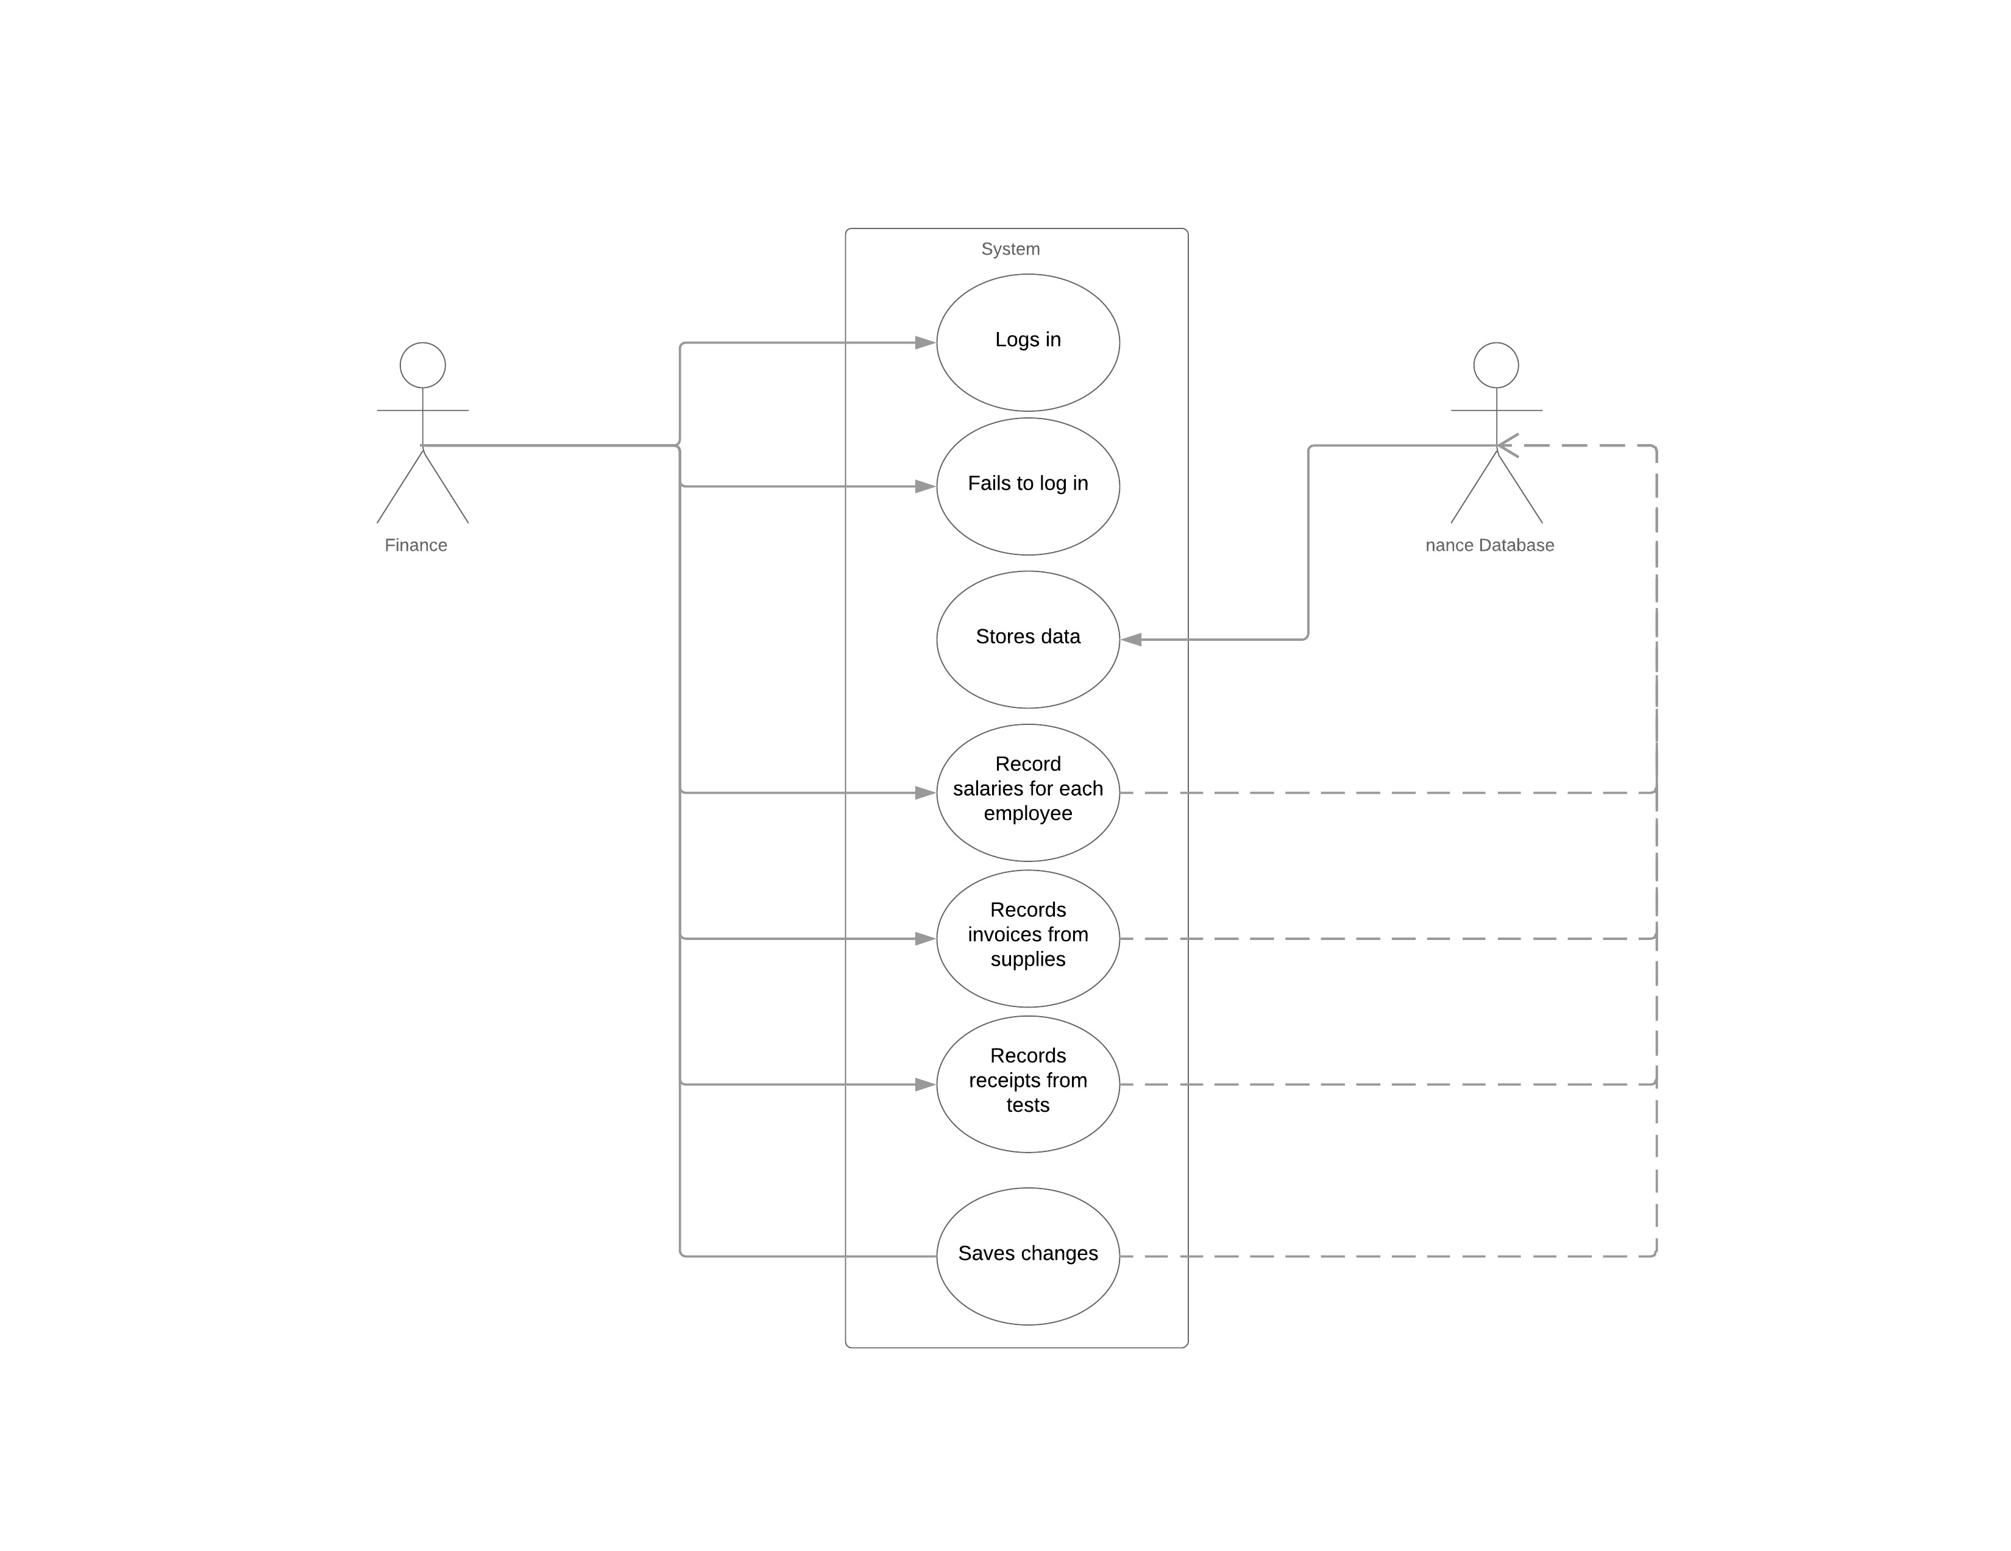

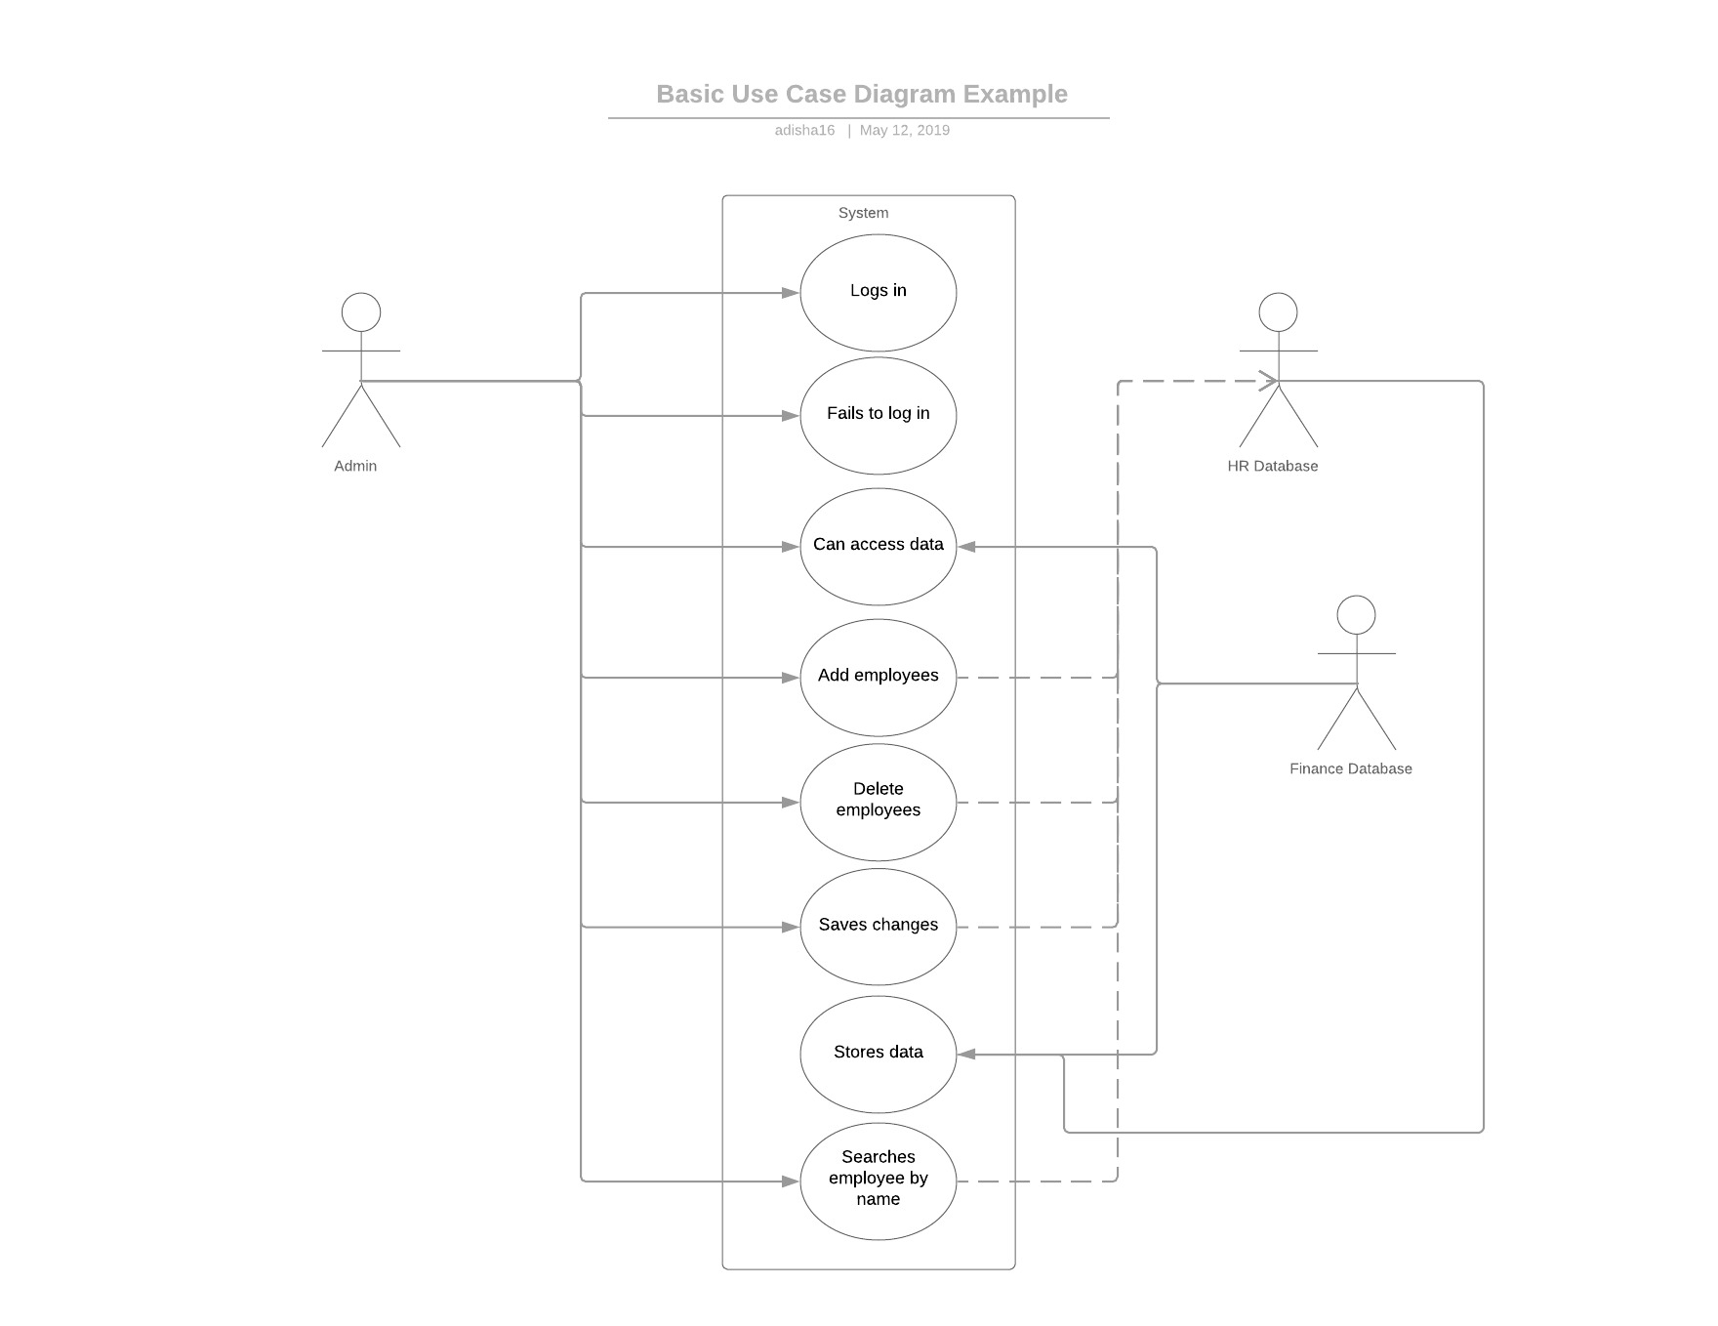

Activity Diagrams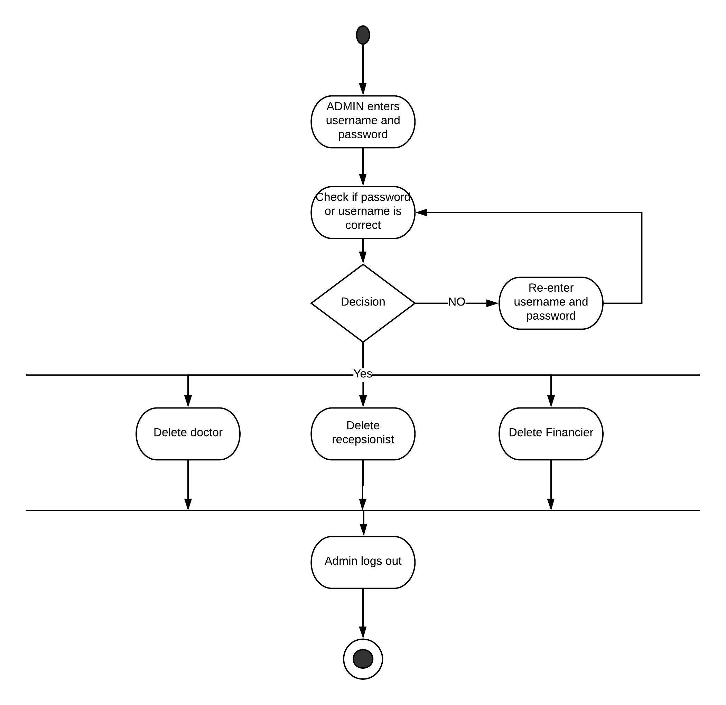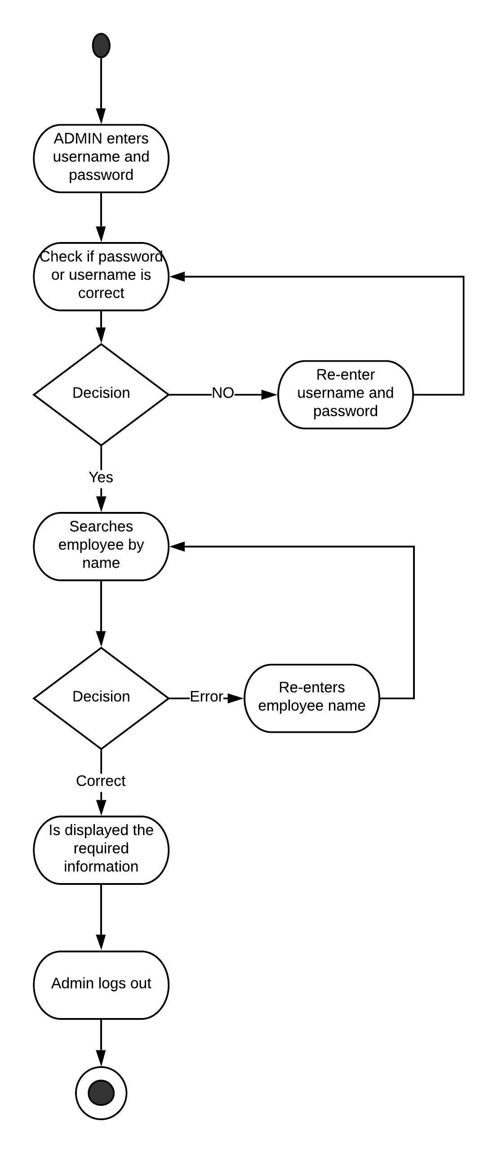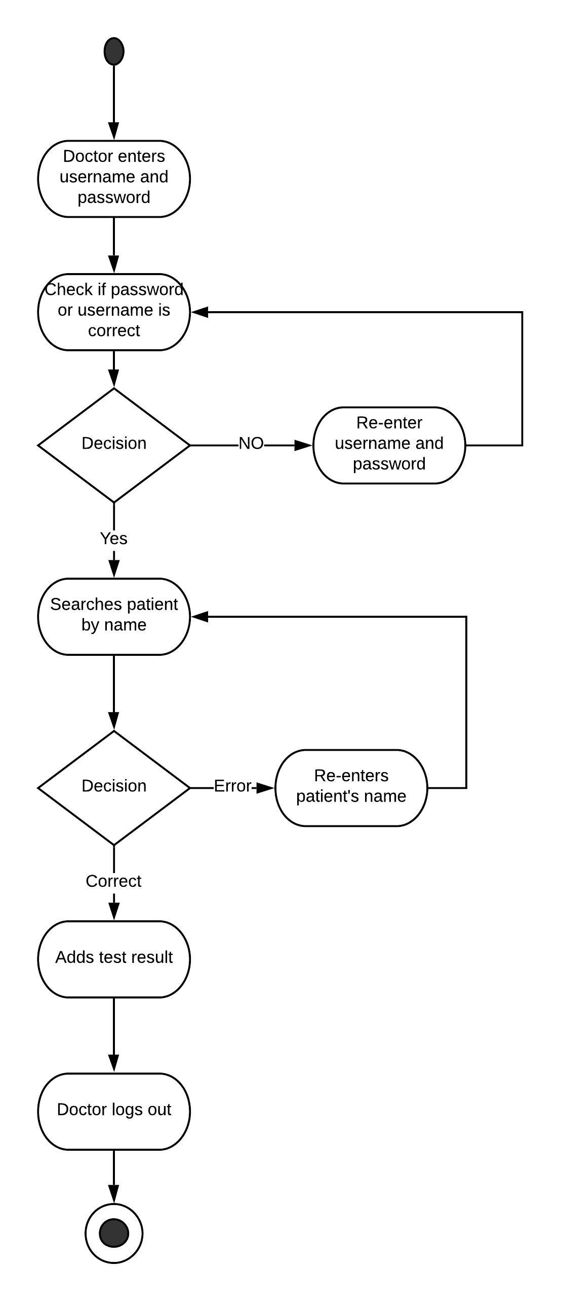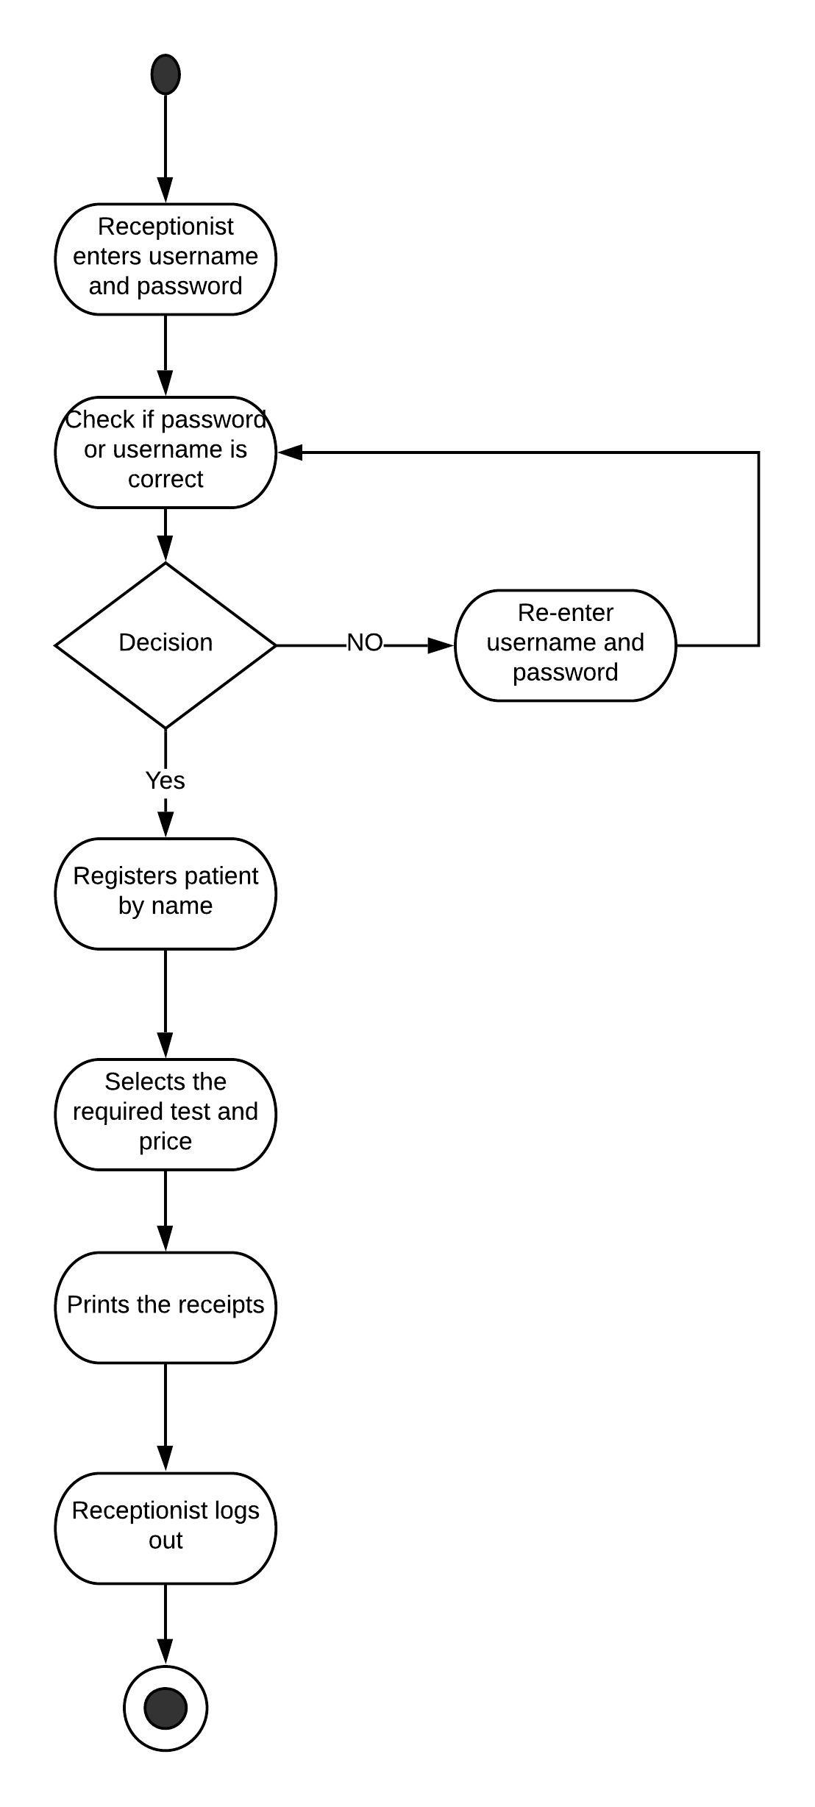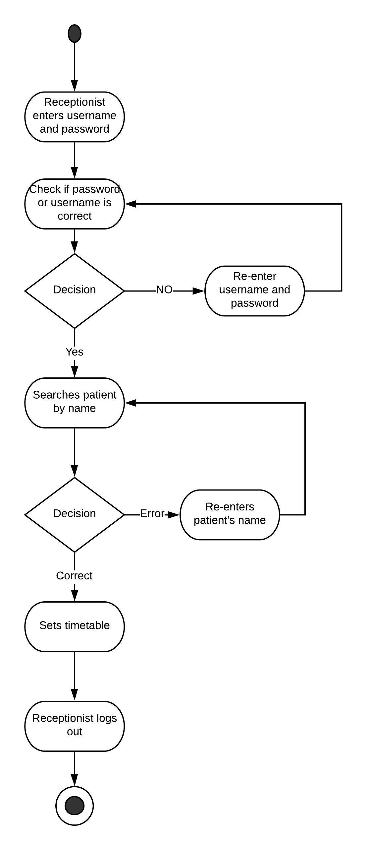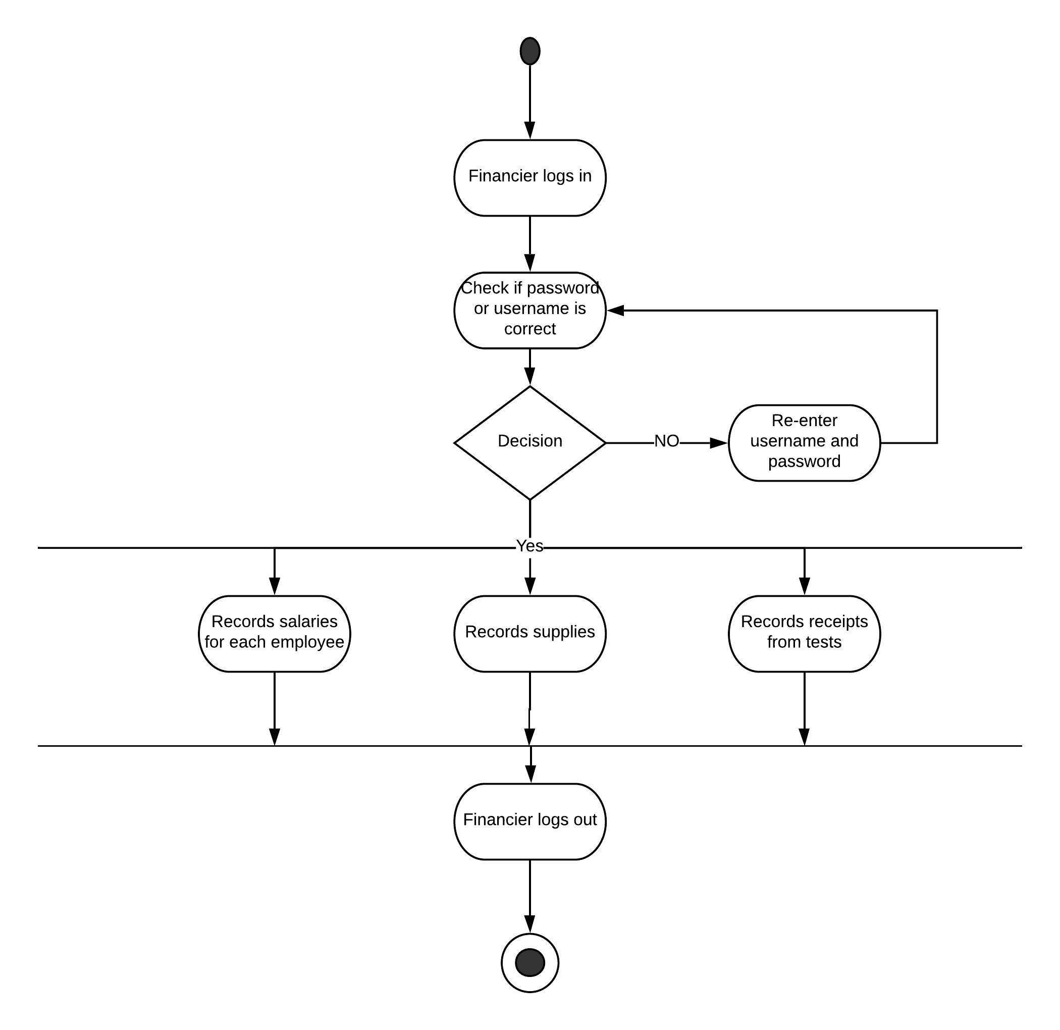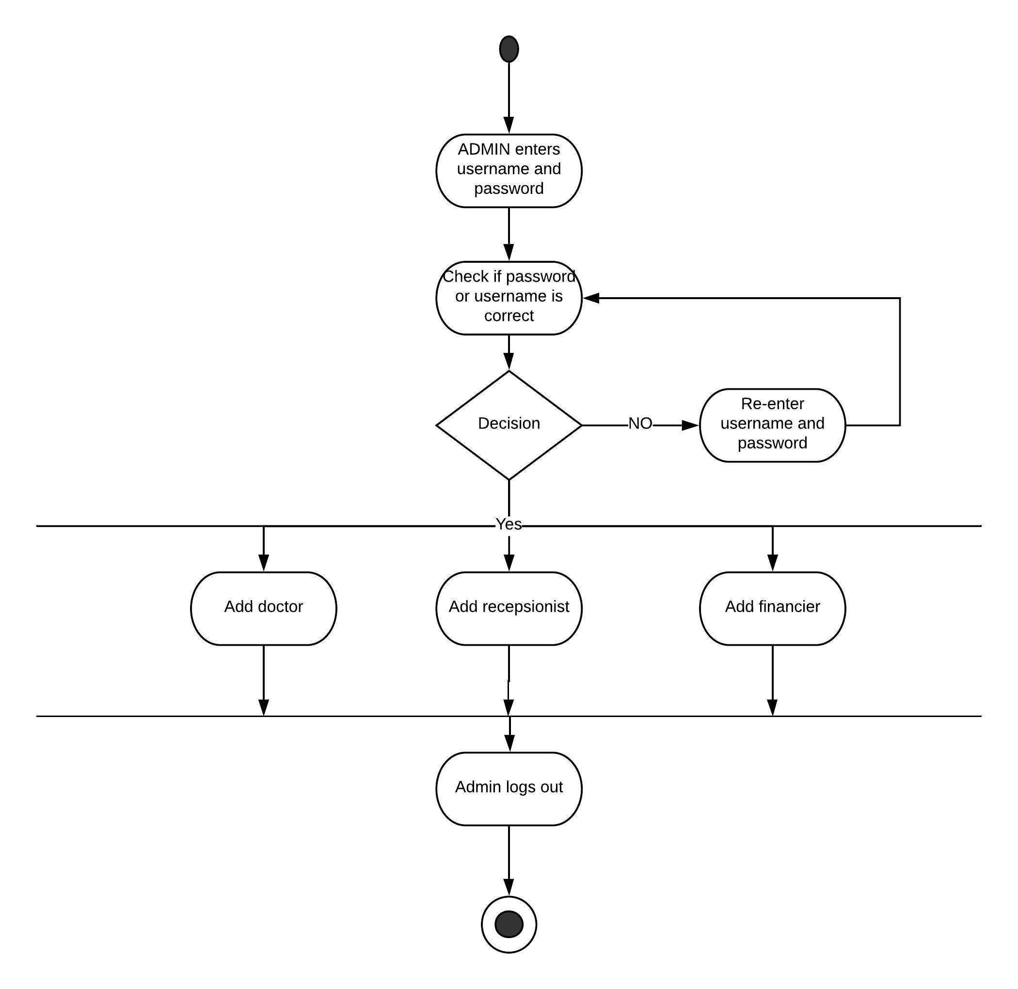

State Diagrams
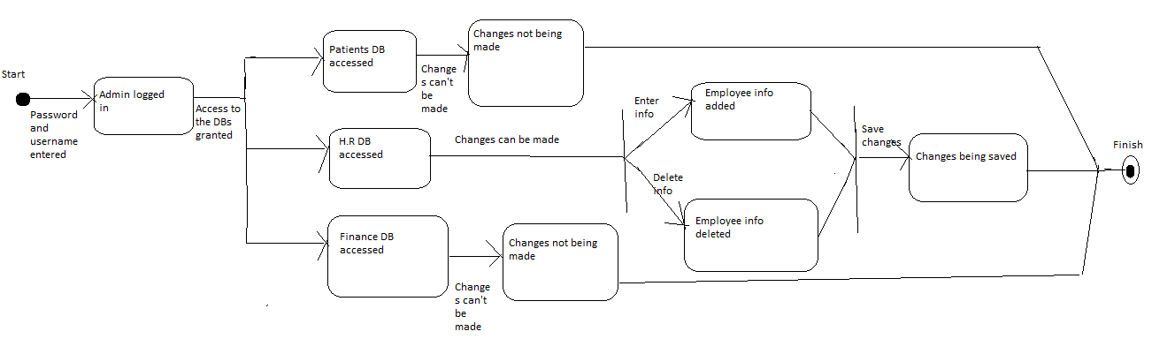
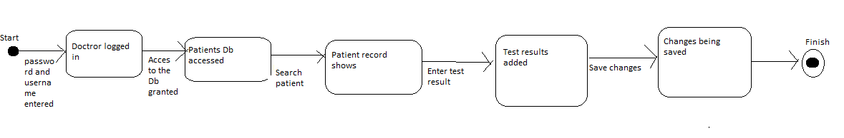
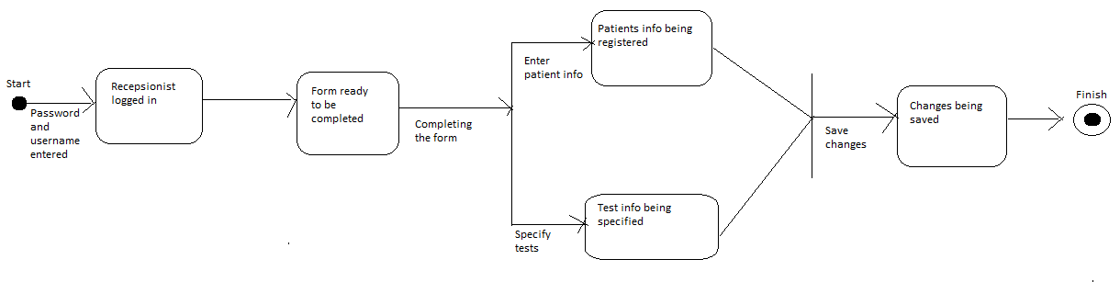
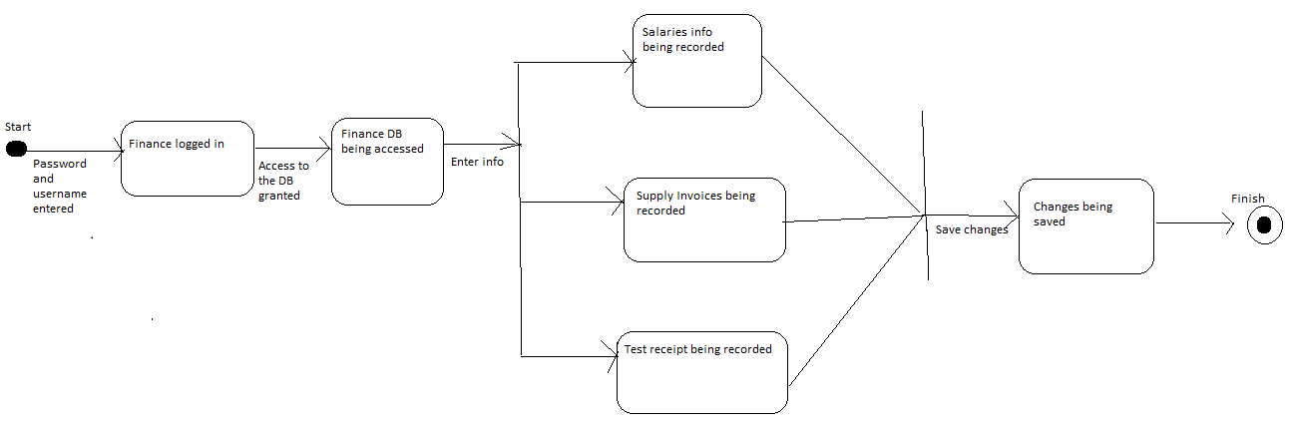
Class Diagram
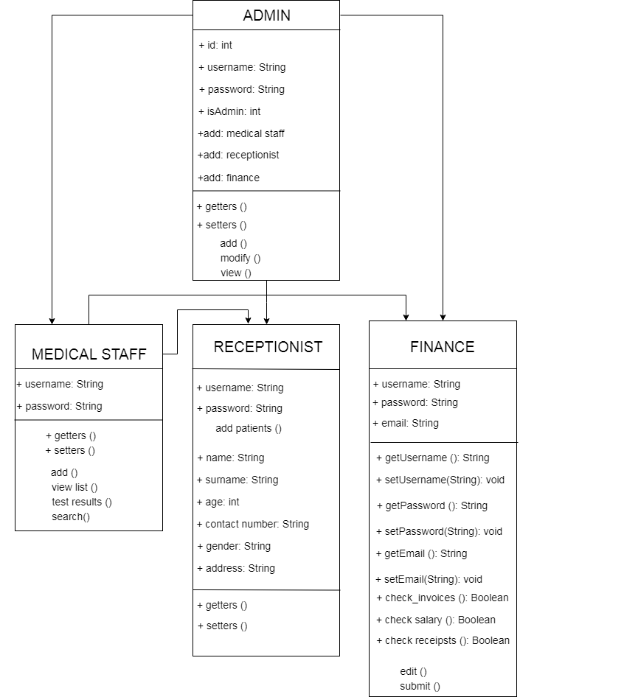

Sequence Diagram
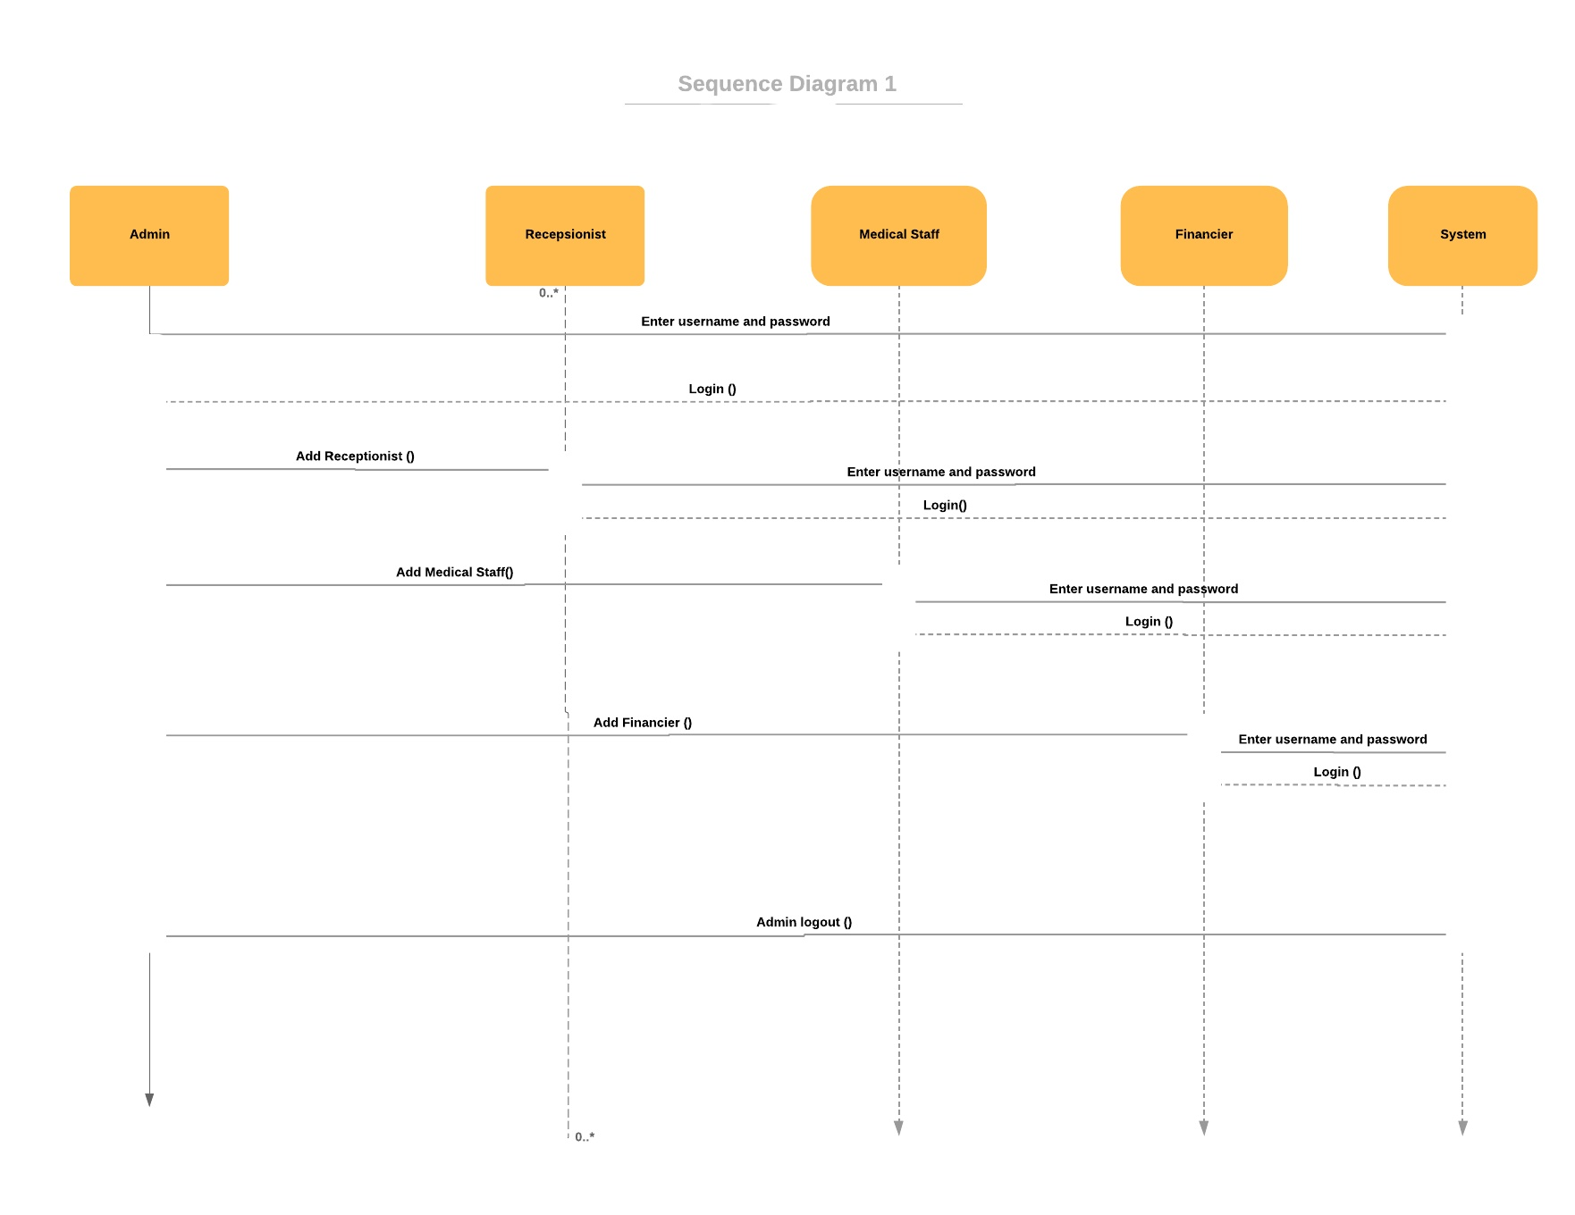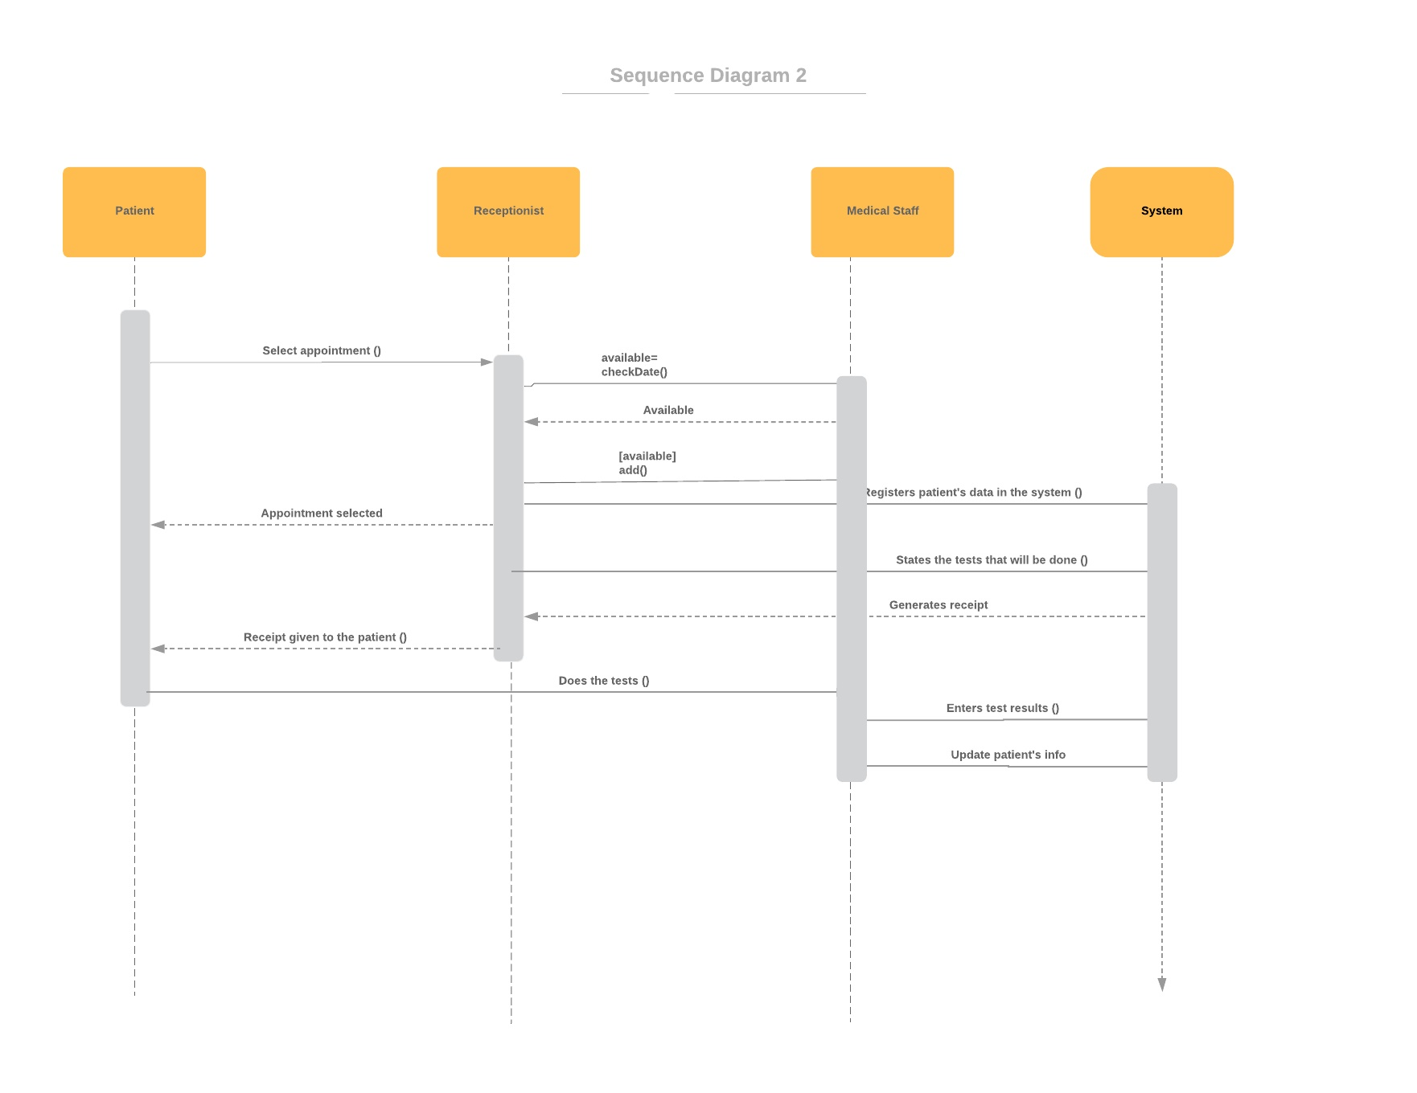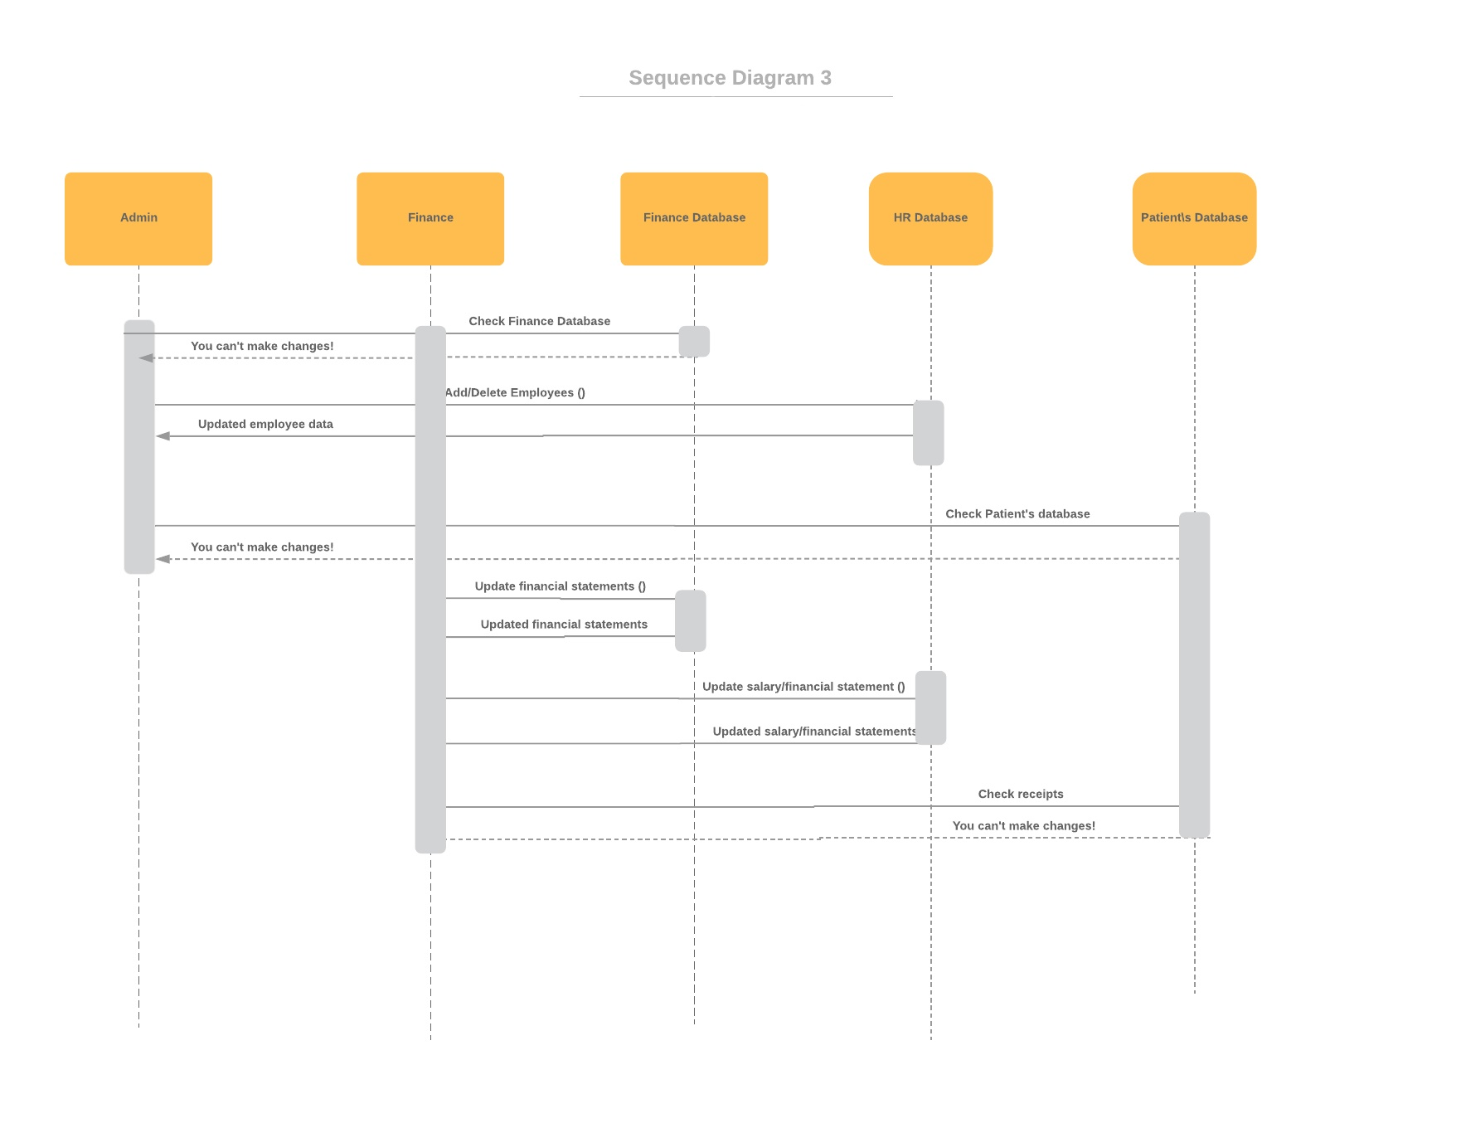
DFD Diagrams
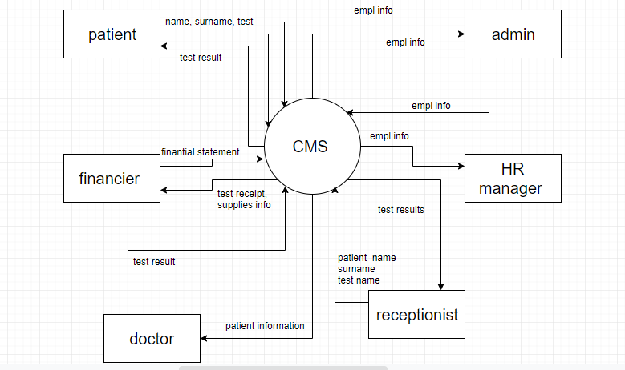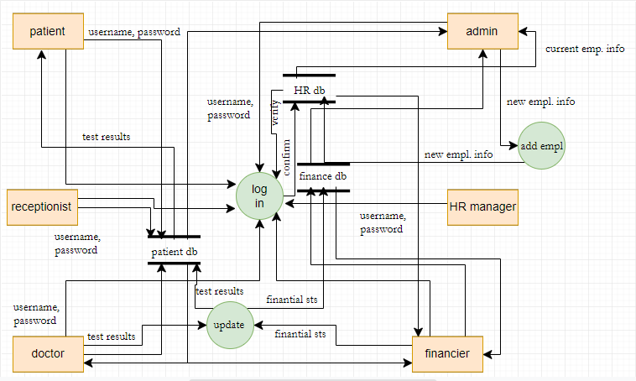

ERD Diagrams
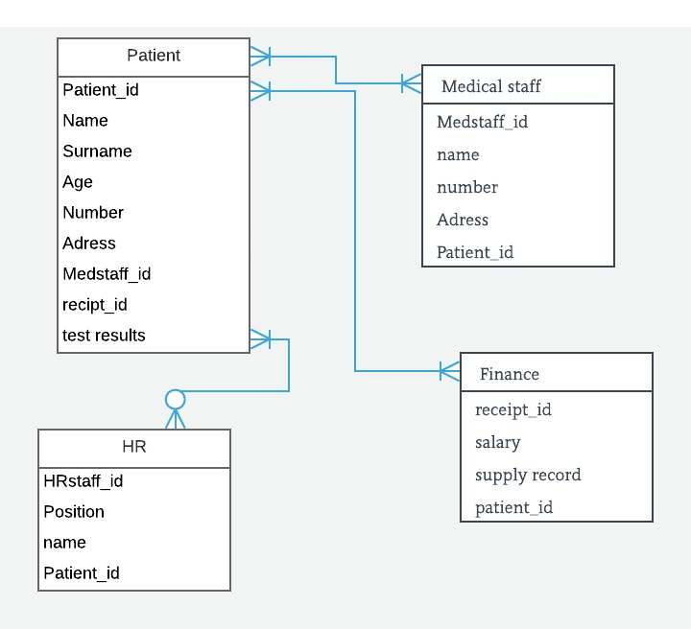
APPENDIX
The appendixes are not always considered part of the actual Requirements Specification and are not always necessary. They may include
- Sample input/output formats, descriptions of cost analysis studies, or results of user surveys;
- Supporting or background information that can help the readers of the Requirements Specification;
- A description of the problems to be solved by the system;
- Special packaging instructions for the code and the media to meet security, export, initial loading, or other requirements.
When appendixes are included, the Requirements Specification should explicitly state whether or not the appendixes are to be considered part of the requirements.
- Definitions, Acronyms, and Abbreviations
Define all terms, acronyms, and abbreviations used in this document.
- References
List all the documents and other materials referenced in this document.
- Requirements Traceability Matrix
The following trace matrix examples show one possible use of naming standards for deliverables (FunctionalArea-DocType-NN). The number has no other meaning than to keep the documents unique. For example, the Bargaining Unit Assignment Process Flow would be BUA-PF-01.
For example (1):
Business Requirement | Area | Deliverables | Status
BR_LR_01  The system should validate the relationship between Bargaining Unit/Location and Job Class.---Comments: Business Process = "Assigning a Bargaining Unit to an Appointment" (Priority 1) | BUA | BUA-CD-01  Assign BU Conceptual Design | Accepted
 | BUA | BUA-PF-01  Derive Bargaining Unit-Process Flow Diagram | Accepted
 | BUA | BUA-PF-01  Derive Bargaining Unit-Process Flow Diagram | Accepted
BR_LR_09  The system should provide the capability for the Labor Relations Office to maintain the job class/union relationship.---Comments: Business Process = "Maintenance" (Priority 1) | BUA | BUA-CD-01  Assign BU Conceptual Design | Accepted
 | BUA | BUA-PF-02  BU Assignment Rules Maint Process Flow Diagram | ReadyForReview
For example (2):
BizReqID | Pri | Major Area | DevTstItems DelivID | Deliv Name | Status
BR_LR_01 | 1 | BUA | BUA-CD-01 | Assign BU Conceptual Design | Accepted
BR_LR_01 | 1 | BUA | BUA-DS-02 | Bargaining Unit Assignment DB Modification Description | Accepted
BR_LR_01 | 1 | BUA | BUA-PF-01 | Derive Bargaining Unit-Process Flow Diagram | Accepted
BR_LR_01 | 1 | BUA | BUA-UCD-01 | BU Assign LR UseCase Diagram | ReadyForReview
BR_LR_01 | 1 | BUA | BUA-UCT-001 | BU Assignment by PC UseCase - Add Appointment and Derive UBU | Reviewed
BR_LR_01 | 1 | BUA | BUA-UCT-002 | BU Assignment by PC UseCase - Add Appointment (UBU Not Found) | Reviewed
BR_LR_01 | 1 | BUA | BUA-UCT-006 | BU Assignment by PC UseCase - Modify Appointment (Removed UBU) | Reviewed
BR_LR_09 | 1 | BUA | BUA-CD-01 | Assign BU Conceptual Design | Accepted
BR_LR_09 | 1 | BUA | BUA-DS-02 | Bargaining Unit Assignment DB Modification Description | Accepted
BR_LR_09 | 1 | BUA | BUA-PF-02 | BU Assignment Rules Maint Process Flow Diagram | Accepted
BR_LR_09 | 1 | BUA | BUA-UCD-03 | BU Assign Rules Maint UseCase Diagram | Reviewed
BR_LR_09 | 1 | BUA | BUA-UCT-045 | BU Assignment Rules Maint: Successfully Add New Assignment Rule | Reviewed
BR_LR_09 | 1 | BUA | BUA-UCT-051 | BU Assignment Rules MaintUseCase: Modify Rule | Reviewed
BR_LR_09 | 1 | BUA | BUA-UCT-053 | BU Assignment Rules MaintUseCase - Review Assignment Rules | Reviewed
BR_LR_09 | 1 | BUA | BUA-UCT-057 | BU Assignment Rules MaintUseCase: Inactivate Last Rule for a BU | Reviewed
BR_LR_09 | 1 | BUA | BUA-UI-02 | BU AssignRules Maint UI Mockups | ReadyForReview
BR_LR_09 | 1 | BUA | BUA-TC-021 | BU Assignment Rules Maint TestCase: Add New Rule (Associated Job Class Does Not Exist) - Success | ReadyForReview
BR_LR_09 | 1 | BUA | BUA-TC-027 | BU Assignment Rules Maint TestCase: Modify Rule - Success | ReadyForReview
BR_LR_09 | 1 | BUA | BUA-TC-035 | BU Assignment Rules Maint TestCase: Add New Rule (Associated Job Class Does Not Exist) - Error Condition | ReadyForReview
BR_LR_09 | 1 | BUA | BUA-TC-049 | BU Assignment Rules Maint TestCase: Modify Rule - Error Condition | ReadyForReview
For example (3):
BizReqID | CD01 | CD02 | CD03 | CD04 | UI01 | UI02 | UCT01 | UCT02 | UCT03 | TC01 | TC02 | TC03 | TC04
BR_LR_01 |  |  | X |  | X |  | X |  |  | X |  | X
BR_LR_09 | X |  |  | X |  | X |  |  | X |  | X |  | X
BR_LR_10 | X |  |  | X |  |  |  |  | X |  | X
BR_LR_11 |  | X
- Organizing the Requirements
This section is for information only as an aid in preparing the requirements document.
Detailed requirements tend to be extensive. Give careful consideration to your organization scheme. Some examples of organization schemes are described below:
By System Mode
Some systems behave quite differently depending on the mode of operation. For example, a control system may have different sets of functions depending on its mode: training, normal, or emergency.
By User Class
Some systems provide different sets of functions to different classes of users. For example, an elevator control system presents different capabilities to passengers, maintenance workers, and fire fighters.
By Objects
Objects are real-world entities that have a counterpart within the system. For example, in a patient monitoring system, objects include patients, sensors, nurses, rooms, physicians, medicines, etc. Associated with each object is a set of attributes (of that object) and functions (performed by that object). These functions are also called services, methods, or processes. Note that sets of objects may share attributes and services. These are grouped together as classes.
By Feature
A feature is an externally desired service by the system that may require a sequence of inputs to affect the desired result. For example, in a telephone system, features include local call, call forwarding, and conference call. Each feature is generally described in a sequence of stimulus-response pairs, and may include validity checks on inputs, exact sequencing of operations, responses to abnormal situations, including error handling and recovery, effects of parameters, relationships of inputs to outputs, including input/output sequences and formulas for input to output.
By Stimulus
Some systems can be best organized by describing their functions in terms of stimuli. For example, the functions of an automatic aircraft landing system may be organized into sections for loss of power, wind shear, sudden change in roll, vertical velocity excessive, etc.
By Response
Some systems can be best organized by describing all the functions in support of the generation of a response. For example, the functions of a personnel system may be organized into sections corresponding to all functions associated with generating paychecks, all functions associated with generating a current list of employees, etc.
By Functional Hierarchy
When none of the above organizational schemes prove helpful, the overall functionality can be organized into a hierarchy of functions organized by common inputs, common outputs, or common internal data access. Data flow diagrams and data dictionaries can be used to show the relationships between and among the functions and data.
Additional Comments
Whenever a new Requirements Specification is contemplated, more than one of the organizational techniques given above may be appropriate. In such cases, organize the specific requirements for multiple hierarchies tailored to the specific needs of the system under specification.
There are many notations, methods, and automated support tools available to aid in the documentation of requirements. For the most part, their usefulness is a function of organization. For example, when organizing by mode, finite state machines or state charts may prove helpful; when organizing by object, object-oriented analysis may prove helpful; when organizing by feature, stimulus-response sequences may prove helpful; and when organizing by functional hierarchy, data flow diagrams and data dictionaries may prove helpful.

